**Allegations Against Our People**

**Contents**

1. **Policy Statement**
2. **Purpose**
3. **Statutory Guidance**
4. **Scope**
5. **LADO – Local Authority Designated Officer**
6. **Thresholds for Allegations Procedures**
7. **Allegations or Concerns**
8. **Suitability to Work with Children or Adults at risk**
9. **Roles**
10. **Underlying Principles**
11. **Children First**
12. **Adult Social Care**
13. **Process**
14. **Outcomes**
15. **References**
16. **DBS**
17. **Regulated Activity**
18. **Learning Lessons**
19. **Appendices** 
    1. Liverpool FC Foundation Reporting Process
    2. Premier League Flowchart – Low Level Poor Practice Concern
    3. Premier League Flowchart – Serious Poor Practice, Abuse or Criminal Offence
    4. MBC Knowsley – Reporting Process
    5. MBC Knowsley Allegations against Staff Guidance
    6. Contact Details – Liverpool FC, Knowsley Council, Police, NSPCC.

**Document Control**

**Review and Approvals**

|  |  |  |  |
| --- | --- | --- | --- |
| **Date of Approval** | **Author** | **Approval Body** | **Date of Issue** |
| 16th June 2021 | John Pout | LFC People and Policy Board | For 1st September 2021 |
| 24th November 2021 | John Pout | Gavin Laws, Chair of LFC Foundation Trustees | 24th November 2021 |
| 31st August 2022 | John Pout  Emma Higgins | Gavin Laws, Chair of LFC Foundation Trustees | 13th October 2022 |
| 14th December 2023 | Nicola Fryer  Emma Higgins | LFC Foundation Board of Trustees | 14th December 2023 |
| 25th September 2024 | Nicola Fryer | Review | 25th September 2024 |
| 12th February 2025 | Nicola Fryer | LFC Foundation Board of Trustees |  |

**Revision History**

|  |  |  |  |
| --- | --- | --- | --- |
| **Version** | **Revision Date** | **Author** | **Summary of Changes** |
| 2 | 9/11/21 | John Pout | 1. Inclusion of Charity Commission as external agency that is the destination for reporting significant substantiated cases. 2. As a result, Policy becomes LFC Foundation specific. Scope is narrowed to only LFC Foundation employees. |
| 3 | 31/08/20  22 | John  Pout  Emma  Higgins | 1. Throughout – amend to make exclusive to LFC Foundation.   Adoption of term ‘colleagues’   1. Section 15 Changes to references for substantiated allegations. 2. Section 18 – Changes to Lessons Learnt. Appendix A – Inclusion of Chair of Trustees in notification chain. |
| 4 | 14/12/2024 | Nicola Fryer  Emma  Higgins | Throughout the document the term vulnerable adults is replaced with adults at risk or adults.   1. Addition of Working Together to Safeguard Children Legislation. 2. Statement to support reporting all concerns. 3. Addition of contractors that are included as adults who work with children at LFC Foundation. Types of concern made clear as per Keeping Children Safe in Education (KCSIE) (2023). Education Act 2011 included as the most recent version. Working Together added as relevant legislation linked to Allegations. 4. Contractors added for expectations of them to report also. 5. Inclusion of the harm test to determine if the allegation needs to be referred to LADO.   6. Addition of harm threshold and Low level Concern to establish the different types of allegation. Allegations outside of the work environment included. Transferable risk to be assessed. Reference to Low Level Concerns for allegations that do not meet the harm threshold.  4 categories of abuse added. |
|  |  |  | 7. LFC Safeguarding Policy and LFC Low level Concerns Policy referenced as policies also needing to be followed. Addition of Senior Safeguarding lead = J Bamber. Addition of Employee Relations Manager – a new role now involved in this process. Director of Safeguarding number added due to Safeguarding hotline no longer in use.   1. Welfare of the child included as paramount for all roles. Lorna Duckworth added. 2. Contractors added as groups that the principles are applicable to. Reference to the new Reporting Policy.   11.Welfare of the child is paramount.   1. ‘Immediately’ added to provide clarity for staff in terms of reporting time scales. Amendment to title of Director of Football. LFC Foundation Senior Leadership Team and Charity   Commission added   1. KCSIE definition included.   Appendix A – Immediately added to make reporting time clear.  New staff member added.  Appendix B – Low Level Concerns Policy added.  Appendix F – New link added.  Appendix G – Current details, telephone numbers and titles amended. |
| 4 | 25th September 2024 | Nicola Fryer (Director of Safeguarding) | No changes. Trustees signed off continuation of policy 11.12.24 whilst reviews ongoing due to no major changes in KCSIE 2024 |
| 5 | 31st January 2025 | Nicola Fryer (Director of Safeguarding) | KCSIE 2023 quotes updated with KCSIE 2024 quotes.  J Bamber’s and C Vallis title changed throughout.  Appendix G – Safeguarding leader names updated.  QR code added to report Allegations against DOS and DDOS.  Section 13 – time frame of 24 hours added |

# 1. Policy Statement

At Liverpool Football Club Foundation safeguarding is everyone’s responsibility. LFC Foundation acknowledges our duty of care to safeguard and promote the welfare of children and protecting adults at risk. We are fully committed to ensuring best safeguarding practice which reflects statutory duties, defined in Government guidance including; Keeping Children Safe in Education, Care Act 2022, Working Together to Safeguard Children ,data protection legislation and statutory guidance, Premier Leagues standards and Football Association requirements.

At LFC Foundation we will make sure that we safeguard and promote the welfare of all children, young people, and adults at risk, regardless of age, disability, gender, gender reassignment, marriage and civil partnership, sexual orientation, pregnancy and maternity, race, and religion/belief.

At LFC Foundation we have established policies and procedures to safeguard and promote the welfare of children, young people, and adults at risk across all parts of the charity.

The ethos and culture, of shared ownership and responsibility, within the LFC Foundation, ensures safeguarding is everybody’s responsibility.

At LFC Foundation, our people, including volunteers, receive training and support to keep children and adults at risk safe, and we ensure our safeguarding policy and procedures are put into practice robustly on a consistent basis. We maintain a safe and positive environment and empower our people to listen to the concerns of children, young people, and adults at risk, and act in accordance with our safeguarding policy and procedures. This is part of the LFC Foundation’s culture of vigilance to deter unsuitable people from seeking to work at the club.

# 2. Purpose

At LFC Foundation, we support a culture that enables our people to feel confidant to report any concern, no matter how small. We put the needs of children, and adults at risk first.

This policy is intended to ensure all children, young people and adults at risk have the same protection regardless of age, disability, gender, gender reassignment, marriage and civil partnership, sexual orientation, pregnancy and maternity, race, and religion/belief.

It provides an embedded procedure for reporting concerns, assurance of receiving a response, how feedback will be received on any action taken and how to further pursue the matter if a team member is not satisfied.

# 3. Statutory Framework

**Keeping Children Safe in Education 2024 part 4**:

Allegations against our people; staff, volunteers, contractors and partners

Provides information on how we should manage allegations against our people that might indicate that they pose a risk to children. The referral to Local Authority Designated Officer (LADO) procedure followed will depend heavily on the circumstances of a particular case and can range from:

1. Does not meet LADO referral threshold, but still warrants LFC Foundation investigation.
2. Meets LADO referral threshold, but no action being taken,
3. Multi-agency strategy discussion,
4. Criminal investigation
5. And/or dismissal of the staff member concerned.

Keeping Children Safe in Education (KCSIE 2024) states that: Organisations and agencies working with children and families should have clear policies for dealing with allegations against adults who work with children. We make a clear distinction between an allegation, a concern about the quality of care or practice, peer on peer abuse or a complaint.

This policy follows KCSIE (2024) guidance and includes two levels of concerns and allegations;

* 1. Concerns / allegations that may meet the harm threshold
  2. Concerns / allegations that do not meet the harm threshold – referred to for the purpose of this policy as ‘Low Level Concerns’ (Please refer to LFC Low Level Concerns Policy)

**Education Act 2004 and 2011**

The Education Act 2004 and 2011 places a statutory duty on Premier League clubs to make arrangements to ensure that in discharging their functions, they have regard to the need to safeguard and promote the welfare of children and that any services they contract out to others are provided having regard to that need.

**Children Act 2004**

Section 11 of the Children Act 2004 places duties on a range of organisations and individuals to ensure their functions, and any services that they contract out to others, are discharged having regard to the need to safeguard and promote the welfare of children.

**Working Together to Safeguard Children (2023)**

Any allegation against people who work with children should be reported immediately to a senior manager within the organisation or agency. The designated officer, or team of officers, should also be informed **immediately** of all allegations that come to an employer’s attention or that are made directly to the police.

There are clear policies in line with those from the Knowsley Safeguarding Children Partnership for dealing with allegations against people who work with children. An allegation may relate to a person who works with children who has:

* Behaved in a way that has harmed a child, or may have harmed a child;
* Possibly committed a criminal offence against or related to a child; or
* Behaved towards a child or children in a way that indicates they may pose a risk of harm to children.
* Behaved or may have behaved in a way that indicates they may not be suitable to work with children.

# 4. Scope

This policy should be used by all team members, volunteers, contractors and visitors who visit or attend sessions organised by LFC Foundation.

This policy is written in accordance with the Liverpool and Knowsley Safeguarding Children Partnership procedures, Keeping Children Safe in Education, the Football Association, English Football League (EFL) and Premier League regulations.

Whereas this policy relates to allegations against adults working with children and adults at risk, if there are allegations relating to adults working with adults (over 18) then these should still be reported as below, and a referral will be made to Adult Social Care. LFC Foundation includes adults requiring Safeguarding and / or welfare support as Adults at Risk, all Academy players, male and female over 18, and those adults where situational or contextual circumstances make them vulnerable.

# 5. LADO: Local Authority Designated Officer

Allegations against our people, whether they be contracted, casual, consultants, or volunteers, who work with children, can cover a wide range of circumstances, and may arise from a number of sources (e.g., a report from a child, a concern raised by another adult in the organisation, or a complaint by a parent).

Allegations may arise in the context of a team member and their life outside work, online or at home. Our people can seek support from HR on private matters that may involve social care or police. All matters will be handled sensitively and supportively.

If an adult satisfies the harm test (ie. they may harm or put at risk of harm a child or adult at risk) a referral must be made to the LADO.

# 6. Thresholds for Allegations Procedures

Allegations are deemed to have met the harm threshold when an adult who works with children or adults at risk has:

* **behaved in a way that has harmed or may have harmed a child;**
* **possibly committed a criminal offence against or related to a child;**
* **behaved towards a child that indicates they may be a risk to children; or**
* **behaved towards a child in a way that indicates they may not be suitable to work with children.**

An allegation can relate to behaviour outside of work, and their relationship with others, if they;

* behave in their personal life in a manner that raises safeguarding concerns. These do not have to directly relate to children, for example, an arrest for possession of a weapon.
* as a parent or carer, become subject to child protection procedures.
* are closely associated with someone in their personal lives who may present a risk of harm to children for whom the adult is responsible in employment / volunteering.

Where appropriate, an assessment of transferable risk to children with whom the person works will be undertaken, and advice sought from the LADO.

Allegation procedures need to be applied with common sense whilst being and remaining non-judgmental.

Many cases may well either not meet the criteria set out above ,or, may do so without warranting consideration of either a police investigation or enquiries by local authority children's social care services. In these cases, we follow our safeguarding and Low Level Concerns Policy to resolve cases without delay.

* These behaviours should be considered within the context of the four categories of abuse (ie. Physical, sexual, emotional and neglect). These will include concerns relating to inappropriate relationships between team members and children or young people, for example:
  + inappropriate behaviour or blurring of boundaries with a child under 18 if in a position of trust in respect to that child, even if it is consensual.
  + having a sexual relationship with a child under 18 if in a position of trust in respect of that child, even if consensual
  + ['Grooming',](https://westmidlands.procedures.org.uk/page/glossary?term=Grooming&g=3kjN#gl31) i.e. meeting a child under 16 with intent to commit a relevant offence

(S15 Sexual Offences Act 2003)

* other ['grooming'](https://westmidlands.procedures.org.uk/page/glossary?term=Grooming&g=3kjN#gl31) behaviour giving rise to concerns of a broader child protection nature (for example, inappropriate text/e-mail messages or images, gifts, socialising etc.)
  + seeking to access, viewing or possession of indecent photographs/pseudo photographs of children.

# 7. Allegation or Concern

The alleged concern must be sufficiently serious to suggest harm has or may have been caused to a child and must satisfy the harm thresholds. The individual may pose a risk to children (see criteria above).

If the concerns do not meet the threshold, they should be addressed by appropriate LFC Foundation procedures namely; LFC Foundation Safeguarding Policy and LFC Foundation Low level Concerns Policy.

**Allegations may relate to the person's behaviour at work, at home, online or in another setting.**

At LFC Foundation all allegations or concerns are referred to the Director of Safeguarding

(DOS). A consultation will be undertaken by the DOS, Independent Safeguarding Consultant (if appropriate), Senior Safeguarding Lead, Human Resources Business Partner, Employee Relations Manager and the LADO to determine whether the allegations criteria has been met.

Referral on allegations to the Director of Safeguarding should be through;

* My Concern
* Fans Website
* Or in extremis contact LFC Director of Safeguarding – 07780 226978

**8. Suitability to work with Children and Adults at risk.**

If allegations or concerns are made about an adult’s behaviour in relation to their own children (or children they have care of), and that person works with children, the LADO should be informed.

Allegations of non-recent (historical) abuse should be responded to in the same way as contemporary concerns.

All allegations or concerns should be referred to your Designated Safeguarding Lead (DSL), your manager, or a member of the Safeguarding Team, **without delay**. Referrals should be confirmed in writing within 24 hours. **See Appendix G for LFC Safeguarding contact details.**

If the allegation is about your DSL or your manager, your referral should be reported to the DOS.

If the allegation relates to LFC Director of Safeguarding or LFC Deputy Director of Safeguarding Foundation DSL, please scan the QR code below and select the staff members name;



Using the above link will ensure that the staff member involved does not see the concern and a Senior Safeguarding member will be notified.

Alternatively, there is a Whistleblowing Policy within the club which you can find in the HR Hub. You can contact the LADO directly or NSPCC Childline – **See Appendix F.**

If a child / young person or adult at risk is in immediate danger, and you require the police or an ambulance call: 999 or 101.

# 9. Roles

The welfare of the child and / or adult at risk is paramount.

**Director of Safeguarding (DOS)**

At LFC Foundation our Director of Safeguarding is Nicola Fryer, who is the Designated Safeguarding Lead to whom allegations or concerns should be reported.

In the absence of the DOS, Lorna Duckworth (Deputy Director of Safeguarding) is the Deputy Designated Safeguarding Lead to whom allegations or concerns should be reported. The DOS ensures that LFC Foundation deals with allegations in accordance with these procedures and manages inter agency contact (Premier League safeguarding, Football Association Safeguarding, LADO, Police, Children’s, or Adults Services as required). The DOS is supported in this by our Safeguarding Team and in partnership with the LADO and Local Safeguarding Partnerships.

**Managers**

Managers are involved in supporting our people throughout the investigation **–** both if reporting the incident or the team member whom the allegation has been made against. For the professional involved, the assessment and subsequent action will be stressful whatever the outcome, and support for each individual must be considered and acted upon.

Support for the person making the referral.

The team member who reports the matter to Safeguarding must respect the confidentiality of the case and not discuss the case with anyone else. They will be supported by the foundation, and if necessary, anonymity will be respected.

All cases will be subject to an initial joint evaluation between the LADO and LFC Foundation, involving relevant sectors as and when appropriate including, the Police, Children’s or Adults social work services, employers, and regulatory bodies.

The assessment will focus on the nature of the concern, safeguarding for the particular child/children, or adults, and appropriate consideration for the team member/volunteer involved.

An allegations strategy meeting will be convened where necessary to agree an appropriate way forward.

# 10. Underlying Principles

When dealing with allegations against our people, contractors or volunteers, the following principles should be applied:

Confidentiality

Every effort should be made to maintain confidentiality and guard against publicity while an allegation is being investigated. Apart from keeping the child, parents and accused person (where this would not place the child at further risk) up to date with the progress of the case, information should be restricted to those who have a need to know to protect children, facilitate enquiries, and manage related disciplinary processes. LFC Foundation must maintain its Duty of Care to all involved. This includes not contacting the person or the accusers, without the authority of the DOS or the HR Business Partner (HRBP).

Case Management Documentation

All allegations must follow LFC Foundation Reporting Policy, and all documentation related to the individual case shall be stored in My Concern, LFC Foundation’s case management system.

This is compliant with Data Protection and GDPR. The case will be stored in the section for staff matters, and therefore not available to other team members outside of the LFC Safeguarding team, without the authority of this team.

# 11. Children First

The welfare of the child is paramount.

The protection of a child/young person or adult at risk will be the prime consideration in the process of managing an allegation.

The child/young person’s involvement in the process including support and feedback will be given careful consideration with the LADO and children’s social care ensuring that the child’s voice is heard.

12. **Adult Social Care**

Allegations relating to the abuse of over 18’s will be dealt with by Adult Social Care.

# 13. Process

All our people, contractors and volunteers must report any allegations to the Director of Safeguarding **immediately**, or as soon as is reasonably possible (this must be within 24 hours of the allegation becoming known).

Following an allegation being made the Director of Safeguarding at LFC Foundation will inform the LADO without delay and within one working day prior to any further investigation taking place. We will continue to liaise and work in partnership throughout this process with the LADO and our Local Safeguarding Partnerships.

After the LADO decision;

* The Chief Legal officer will be notified (if not already aware), a case manager appointed – normally the Director of Safeguarding, who will work with the HR Business Partner for that department, and, in consultation with the LADO where appropriate an Independent Investigating Officer may be appointed.
* The DOS will be the LFC Foundation leader on the case and will work with other leaders across LFC Foundation, as necessary.
* The decision as to when or not to inform the parents or carers of the child or children will be made on a case-by-case basis. This decision will be made in consultation with the LADO, as this may impede the disciplinary or investigation processes.
* In some circumstances the parent/carer may need to be told straight away for example if the child is injured and requires medical treatment.
* The parent/carer and the child, should be helped to understand the processes involved and kept informed about the progress of the case and of the outcome where there is no criminal prosecution. This will include the outcome of any Disciplinary process but not details of a hearing.
* LFC Foundation has a duty of care to our people. We will act to manage and minimise the stress inherent in the allegations process. Support for the individual is vital to fulfilling this duty. Individuals should be informed of concerns or allegations as soon as possible and the likely course of action explained unless there is an objection by the children’s social care services or the police.
* Subject to restrictions on the information that can be shared, we will, as soon as possible, inform the team member whom the allegation has been made against. This will be carried out, by agreement, by one of either the Director of Safeguarding, HRBP or line manager. It will include;
* the nature of the allegation,
* how enquiries will be conducted,
* the possible outcome (e.g., disciplinary action, and dismissal, or referral to the DBS and/or regulatory body).

The team member whom an allegation has been made against should:

* Be supported by their manager and HR and treated fairly and honestly and helped to understand the concerns expressed and processes involved.
* They should be kept informed of the progress and outcome of any investigation and the implications for any disciplinary or related process.
* Managers, and HR, will need to consider further support for the team member if it is appropriate for them to return to work following the investigation.
* The FA and Premier league safeguarding teams will be notified of all allegations or concerns about any team members. **See Appendix B and C.**
* The Foundation Senior Leadership Team will be notified of any concerns or allegations against a team member so they can maintain oversight.
* The LFC Foundation Board may also be informed of an allegation and / or decision to allow consideration for a referral to The Charity Commission.

# 14. Outcomes

1. **Substantiated**

There is sufficient evidence to prove the allegation that a child has been harmed or there is a risk of harm.

If the facts of the incident are found to be true but it is not found that a child has been harmed or there is a risk of harm, then consideration should be given to deciding that the outcome is 'unsubstantiated' or 'unfounded'.

1. **Malicious**

There is sufficient evidence to disprove the allegation and there has been a deliberate act to deceive or cause harm to the person subject to the allegation. The case leader may consider exploring if the person involved has been abused and is searching for help, police may be asked to consider what action may be appropriate in these circumstances, or internal disciplinary processes may be followed.

1. **False**

There is sufficient evidence to disprove the allegation, however, there is no evidence to suggest that there was a deliberate intention to deceive. False allegations may be an indicator of abuse elsewhere which requires further exploration. If an allegation is demonstrably false, the Foundation in consultation with the LADO, should refer the matter to Local Authority children's social care to determine whether the child is in need of services, or might have been abused by someone else.

1. **Unsubstantiated**

There is insufficient evidence to either prove or disprove the allegation. The term, therefore, does not imply guilt or innocence**.**

1. **Unfounded**

There is no evidence or proper basis which supports the allegation being made. It might also indicate that the person making the allegation misinterpreted the incident or was mistaken about what they saw. Alternatively, they may not have been aware of all the circumstances.

# 15. References

It is LFC Foundation HR policy, that where an allegation is proven to be false, unsubstantiated, unfounded, or malicious it should not be included in references. A history of repeated concerns or allegations which have all been found to be false, unsubstantiated, or malicious should also not be included in any reference.

Where an allegation is proven to be substantiated and where the LADO process concludes that one or more of the thresholds has been met, LFC Foundation has a duty to disclose this to potential employers. This applies to LFC Foundation team members who are seeking employment elsewhere, regardless of the reason for termination. This will be done, only, if the post involves working with children or adults at risk.

For applicants to LFC Foundation, we follow Statutory Guidance (KCSIE 2024), ‘any information about past disciplinary action or allegations that are disclosed should be considered carefully when assessing the applicant’s suitability for the post.’

**16. DBS**

Following the outcome of the investigation, the Foundation has a legal duty to refer to DBS where conditions are met. This applies even when a referral has also been made to a local authority safeguarding team or professional regulator.

# 17. Regulated Activity

As a regulated activity provider, the foundation must make a referral to the FA and Premier League when a team member has carried out any of the following:

* engaged in relevant conduct in relation to children and/or adults, that fits within FA ‘low level concerns’ criteria.
* An action or inaction has harmed a child or adult at risk or put them at risk of harm or;
* satisfied the harm test in relation to children and / or adults at risk. e.g., there has been no relevant conduct but a risk of harm to a child or adult at risk still exists, or
* been cautioned or convicted of a relevant (automatic barring either with or without the right to make representations offence. **See Appendix A and B.**

If applicable, a referral will be made to the Charity Commission.

# 18. Learning Lessons

At the conclusion of a case in which an allegation is substantiated, we will review the circumstances of the case to determine whether there are any improvements to be made to procedures or practice to help prevent similar events in the future.

This review could include commissioning a formal independent enquiry. The lessons learnt will be recorded on the My Concern case.

# 19. Appendices

1. Liverpool FC Reporting Process
2. FA Low Level Concerns
3. Premier League Flowchart – Low Level Poor Practice Concern
4. Premier League Flowchart – Serious Poor Practice, Abuse or Criminal Offence
5. MBC Knowsley – Reporting Process
6. MBC Knowsley – Allegations against staff Guidance
7. Contact Details – Liverpool FC, Knowsley Council, Police, NSPCC.

# Appendix A – LFC Foundation Reporting Process

## Appendix B – Football Association Guidance on Poor Practice

The FA provide some examples of low-level concerns:

* When insufficient care is taken to avoid injuries (e.g. by excessive training or inappropriate training for the age, maturity, experience and ability of players);
* Allowing abusive or concerning practices to go unreported (e.g. a coach who ridicules and criticizes players who make a mistake during a match);
* Allowing hazing (group initiation, intimidation, or bullying) practices to go unreported;
* Placing children or young people in potentially compromising and uncomfortable situations with adults (e.g. inappropriate use by a coach of social media with a young player(s);
* Ignoring health and safety guidelines (e.g. allowing young players to set up goal posts unsupervised by adults);
* Failing to adhere to the club’s codes of practice (e.g. openly verbally abusing the referee);
* Giving continued and unnecessary preferential treatment to individuals.
* Failure to report a welfare or safeguarding concern

If a member of staff, has substantiated breaches on three occasions it will lead to a **referral to the FA for ‘Low Levels Concerns’.**

Please refer to the Low Level Concerns Policy.

# Appendix C - Premier League Flowchart – Low Level Poor Practice Concern

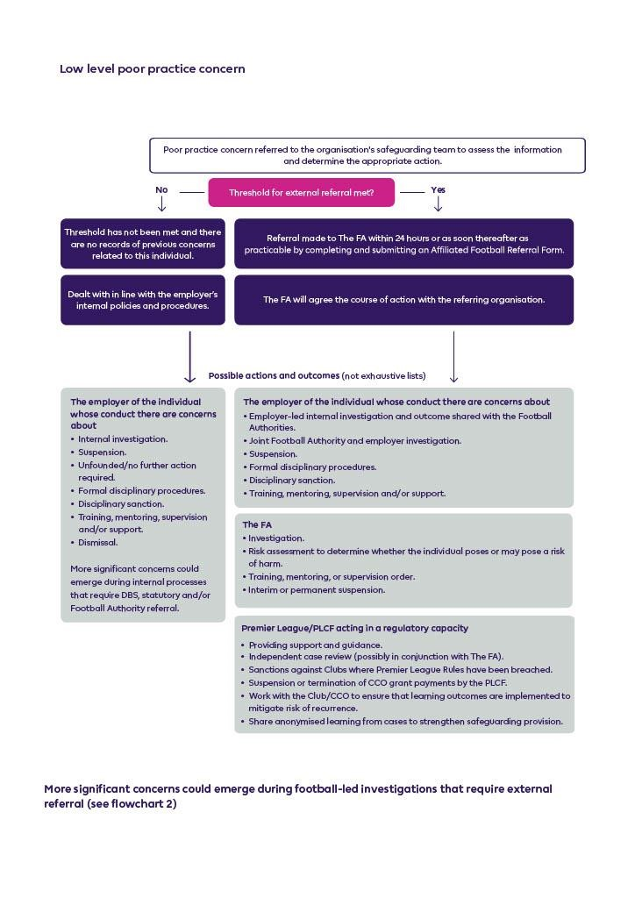

**Appendix D - Premier League Flowchart – Serious Poor Practice, Abuse or Criminal Offence**

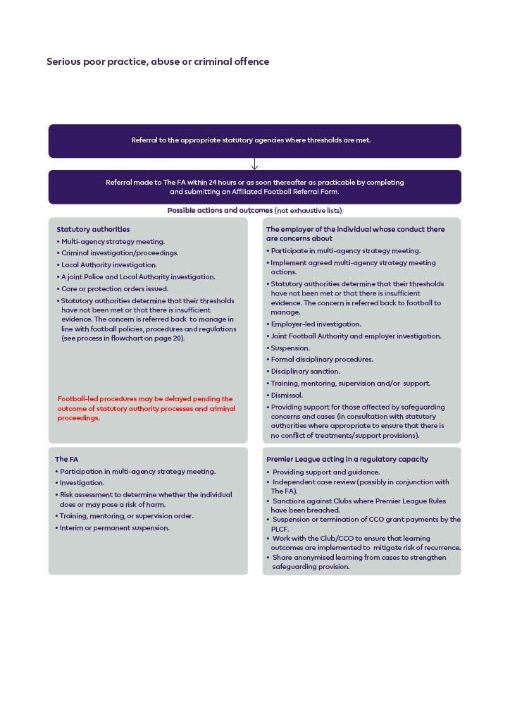

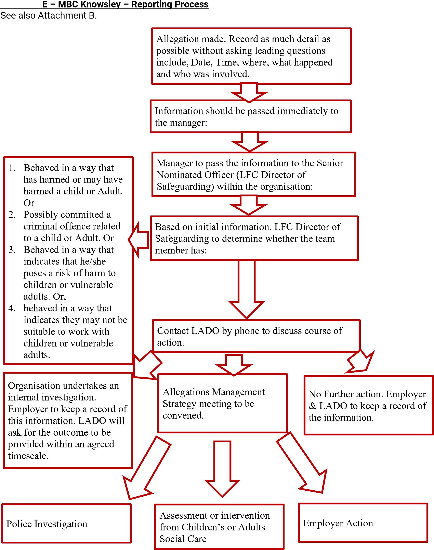

**F – MBC Knowsley Allegations Against Staff Guidance**

Please follow this link to download a PDF Guide. [https://www.knowsleyscp.org.uk/wp-content/uploads/2016/09/Allegations-against-staffhttps://www.knowsleyscp.org.uk/wp-content/uploads/2016/09/Allegations-against-staff-Guidance-for-adults-facing-an-allegation.pdfGuidance-for-adults-facing-an-allegation.pdf](https://www.knowsleyscp.org.uk/wp-content/uploads/2016/09/Allegations-against-staff-Guidance-for-adults-facing-an-allegation.pdf)

**G – Contacts Details – Liverpool FC**, **Knowsley Council, Police, NSPCC**

|  |  |  |  |
| --- | --- | --- | --- |
| Job Title | Name | Mobile Number | Email Address  @liverpoolfc.com |
| Chief Legal officer | Jonathan Bamber | 07841 009093 | @ jonathan.bamber |
| Director of  Safeguarding | Nicola Fryer | 07780 226978 | @nicola.fryer |
| Deputy Director of Safeguarding | Lorna Duckworth | 07841 629809 | @lorna.duckworth |
| Designated Safeguarding Leaders | |  |  |
| Academy | Kieran Baillie | 07554298128 | @kieran.baillie |
| Foundation | Lorna Duckworth | 07841 629809 | @lorna.duckworth |
| International  Academies | Andrew Nicholas | 07526 622975 | @andrew.nicholas |
| Stadium Operations | Lorna Duckworth | 07841 629809 | @lorna.duckworth |
| Liverpool Women’s Football Club | Vicky Buckley-Smyth | 07340498792 | @victoria.buckleySmyth |

## HR

|  |  |  |  |
| --- | --- | --- | --- |
| Job Title | Name | Mobile Number | Email Address |
| VP People and Culture | Carina Vallis | 07905 066182 | @carina.vallis |

## Local Authority Designated Officer

To raise a concern about Liverpool FC staff working with children – Ring Knowsley LADO on 0151 443 3928

## Police

In an emergency ring the Police - 999

**NSPCC** You can ring Childline on 0808 800 5000.

