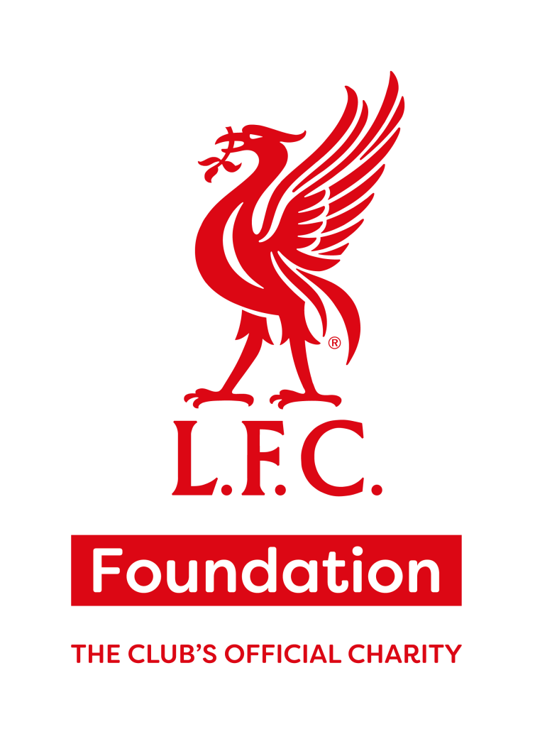

The following codes of conduct have been developed to assist with the smooth running of all LFC Foundation activities. This will ensure the health, safety and protection of the coaches, volunteers, parents, guardians, carers and participants. Please read the code of conduct carefully before agreeing to the terms.
We all have a responsibility to promote high standards of behaviour in sport and at all activities and programmes delivered by the LFC Foundation. Everybody involved has a part to play, so we ask you to follow and respect of codes of conduct.
January 2024
Participants

Whilst participating in LFC Foundation Activities I will:
- Make every effort to develop my abilities in terms of skills & techniques whilst always performing to the best of my ability.
- Respect all other participants and staff members engaged within LFC Foundation programmes.
- Respect the decisions made by any adult involved in delivery and follow the instructions or rules given.
- Listen to staff at all times whilst instructions are being given out.
- Give others the opportunity to speak whilst listening and showing respect.
- Ensure that all LFC Foundation kit, resources and equipment are respectfully treated and cared for.
- Set a positive example for others at all times.
- Respect difference in opinion and in all activities accept success & failure or victory & defeat equally.
- Understand & adhere to my responsibilities and behaviour expectations at any Foundation events. I attend and represent the LFC Foundation whilst at these events.
- Understand that I must conduct myself in a respectful manner at all times.
- Be on time for all activities delivered by the LFC Foundation.
- Be welcoming, inclusive and friendly to all participants who attend sessions. ensuring that everyone values equality, diversity and inclusion.

LFC Foundation staff refuse to accept poor behaviour during sessions, including (but not limited to) the below examples:

- Criticising another participant is not acceptable.
- Do not use offensive, insulting, abusive or discriminatory language/behaviour.
- Be safe at all times, and not engage in physical or verbal abuse.
- Smoking cigarettes or e-cigarettes is not permitted on any site whereby LFC Foundation are delivering activities.
- Do not arrive to a session under the influence of drugs or alcohol.
- Threatening language or behaviours will not be tolerated.

What happens if I do not follow the LFC Foundation Code of Conduct?

The LFC Foundation Code of Conduct is part of our process for making sure that all activities are safe and enjoyable for all. Failure to follow this may result in the below actions being taken to support you and the participants in the sessions.

Minor or first-time incident - Our staff or volunteers will remind you to follow the Code of Conduct and ask you to comply with it. They will give you an opportunity to change your behaviour.

Formal warning - If you continue to not follow the code of conduct after your first reminder, or if your behaviour is more serious, you will be given a formal warning from the programme co Ordinator or manager. They will make a record about what happened (If Under 18 we will inform your parents or carers if this is appropriate). They will also talk with you about what happened and agree what support you need to improve your behaviour in the future. We may also decide that a sanction is appropriate such as restricting you from taking part in some activities.

Final warning - If the support we have put in place isn’t helping you to change your behaviour, we may need to issue a final warning. At this point, we need to meet with you (and if Under 18 with your parents or carers) about other services or strategies that might be more able to give you the support you need. A final warning letter will be sent.
Major Incident – A major incident may result in immediate exclusion from all LFC Foundation activities. If participants are taking part in a school environment the above process will be followed but staff will follow the schools’ behaviour policy alongside the code of conduct, and any meetings will be conducted by school staff.

Parents, Guardians and Carers

- Parents, Guardians and Carers agree to:
- Be responsible for ensuring participants arrive safely and are collected promptly (if a participant is unable to attend or will be collected late, then the LFC Foundation staff must be informed of how the child will be collected safely)
- Inform the LFC Foundation staff in advance if the designated parent/carer cannot collect a participant.
- Set a good example when observing or present at LFC Foundation sessions.
- Promote a positive and inclusive environment.
- Welcome new parents, guardians and carers to ensure that family and friends of the participants feel as welcome to our sessions as much as the participant does.
- Support participants, praise effort as well as performance.
- Promote all activities are primarily there for a person’s enjoyment.
- Remain in the designated area for parents in all activities.
- Encourage respect of all participants and staff.

LFC Foundation staff refuse to accept poor behaviour during sessions, including (but not limited to) the below examples:
- Criticising any participants is not acceptable.
- Smoking cigarettes or e-cigarettes is not permitted on any site whereby LFC Foundation are delivering activities.
- Do not use offensive, insulting, abusive or discriminatory language/behaviour.
- Threatening language or behaviours will not be tolerated.
- Do not arrive to a session under the influence of drugs or alcohol.

What happens if I do not follow the LFC Foundation Code of Conduct?
The LFC Foundation Code of Conduct is part of our process for making sure that all activities are safe and enjoyable for all. Failure to follow this may result in the below actions being taken to support you and the participants in the sessions.
Minor or first-time incident - Our staff or volunteers will remind you to follow the Code of Conduct and ask you to comply with it. They will give you an opportunity to change your behaviour.
Formal warning - If you continue to not follow the code of conduct after your first reminder, or if your behaviour is more serious, you will be given a formal warning from the programme coordinator or manager. They will talk with you about what happened and agree what support you need to improve your behaviour in the future. We may also decide that a sanction is appropriate such as restricting you from observing or attending activities.
Final warning - If the support we have put in place isn’t helping you to change your behaviour, we may need to issue a final warning. At this point, we need to meet with you about other services or strategies that might be more able to give you the support you need. Plans will be made to allow the participants to continue attending if the final warning was ignored. A final warning letter will be sent.
Major Incident – A major incident may result in immediate exclusion from all LFC Foundation activities. If plans cannot be made for another adult to escort the participants to the activity, then the participant will no longer be able to attend.

Staff

We, as staff of Liverpool FC Foundation agree to:
- Respect fully, the human rights of every participant.
- Respect the humanity, dignity, individuality and safety of each participant engaged in our programmes.
- Value equality, diversity and inclusion at LFC Foundation, as per the Equality Act 2010.
- Continue our success by being inclusive in everything we do.
- Follow Health and Safety and Safeguarding Procedures at all times and follow Safer Working Practice Guidance.

We, as staff of Liverpool FC Foundation refuse to behave in any inappropriate ways with any participant attending our programmes; including (but not limited to) the below examples:
- Being alone in a car with a participant or to take a participant home alone.
- To ridicule or reject a young person because of size, shape, gender, sexuality, disability, race or religion.
- To arrange or agree to meet a participant, outside activity times.
- To display any behaviour that could be deemed aggressive, threatening, violent or inappropriate.
- To only make physical contact if it meets the descriptors in the Safer Working Practices expectations.
- To make any comments that may be deemed to be sexual, verbally abusive, threatening or aggressive to any participant.
- To put any of our participants at risk physically, emotionally, socially, verbally or sexually.
- Not to make contact with a participant via social media or disclose personal contact details.

All LFC Foundation staff follow the LFC and Premier League’s expectations on Safer Working Practices.

We, as staff of Liverpool FC Foundation resolve to be examples in word, attitude and behaviour:
- To abide by the club’s safeguarding policies.
- To abide by the LFC and Premier League’s expectations on Safer Working Practices.
- To apply a compassionate, but assertive, non-violent code of discipline.
- To report any suspected cases of abuse or any concern onto My Concern.
- To report facts, not interpret them.
- To provide a safe, secure, enjoyable environment for all participants.
- To risk assess all our delivery venues on KOPD and to complete a dynamic risk assessment on site.
- To record all accidents in accident book.

Any safeguarding concerns should immediately be brought to the attention of the LFC Foundation Safeguarding Team:
- Stephen Hale, Designated Safeguarding Manager – 07785 646368
- Lorna Duckworth, Designated Safeguarding Lead – 07841 629809
- Nic Fryer, LFC Director of Safeguarding – 07780 226978

Alternatively, if your concern is urgent and you can’t get hold of a team member, call NSPPC Hotline (24 hrs) on 0808 800 5000 and then inform a Foundation safeguarding team member.

I understand and agree with the information detailed in this Code of Conduct and will abide by all rules and conditions to uphold the reputation of LFC Foundation. I also agree that failure to do so will result in disciplinary sanctions.

Participant / Parent, Guardian and Carer / Staff

Name: ……………………………………………

Signed: ……………………………………………

Date: ……………………………………………....

Parent, Guardian and Carer if signatory under 18

Signed: ……………………………………………

Date: ……………………………………………....

